Рабочий лист с ответами

Фамилия, имя: ____________________________________________________________________

Схема движения группы.
Парадное крыльцо – зона мастер-классов (2 этаж) – вестибюль (Голографическая инсталляция «Современная Россия») – Зона артефактов «До 1722» – «1722–1917» – «После 1917» – конференц-зал.

- Парадное крыльцо (на улице)

№ 1. In the fresco inside the portico you can see the triumphant people of different jobs and nationalities. Look at the fronton of the building and find the name of their country.
______ The Russian Soviet Federative Socialist Republic __________________

№ 2. The decorations in the fresco also include some frets reflecting the _________ and _________ revolution in the country. Choose two variants:
- industrial;
- space;
- agricultural.

№ 3. The building of the pavilion was built in the style of ‘Stalinist Empire’. This style combines the classical and Soviet elements. Look at the three orders of Greek architecture:
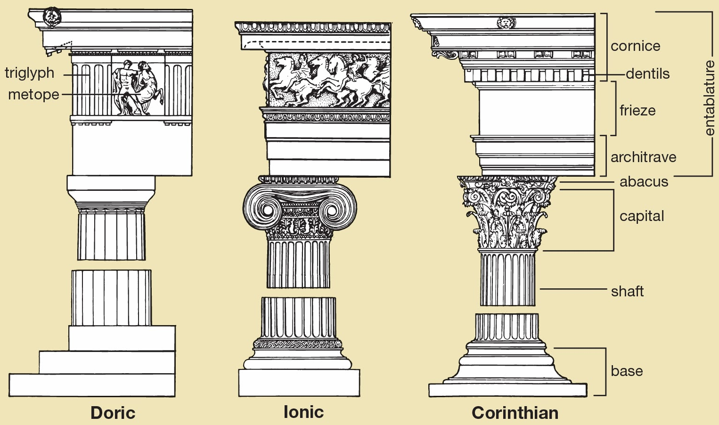

Look for the columns both outside and inside the building. Look at their capitals and identify the orders. __
_ Doric and Corinthian ___________________________________
- Зона мастер-классов (2 этаж).
№ 4. Fill in the form.

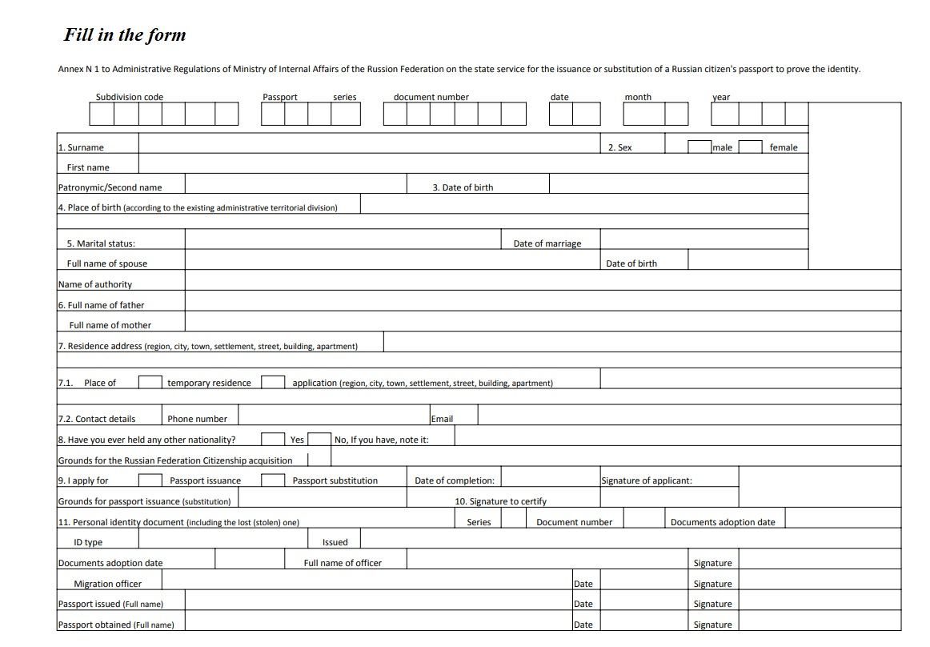

№ 5. Writing. Дополните письмо вашему англоговорящему другу Нику необходмыми словами и знаками препинания. Адрес вашего друга: Россия, Москва, ул. Остоженка, д. 25, кв. 10.
10-25 Ostozhenka St.,
Moscow, Russia
01/09/2019
Dear Nick,
Thank you for your letter. It was great to hear from you!
In your letter you asked me about the procedure of obtaining an identity card. Well, here in Russia we don’t have ID cards. We have passports. This is the main document which we use to certify our identity. Each person gets a passport at the age of 14. It’s very easy to do it. You just have to come to a Multifunctional Centre of Public and Municipal Services with a photo of yours and fill in a special form.
I got mine last year. Now I’m looking forward to getting a driving licence! Ha-ha!
That’s all for now. My favorite TV programme starts.
Write back soon!
Best wishes,
Name of the student

- Голографическая инсталляция «Современная Россия».

№ 6. Watch the installation and mark the statements as ‘True’ or ‘False’.

- The Multifunctional Centers for Provision of State and Municipal Services have been with us for several decades. __F__ (for a few years)
- The interaction has become less stressful. _NS__
- Multifunctional Center for Provision of State and Municipal Services is the center of attraction for citizens living anywhere in the world. _F_ (for residents of the district)
- People come to the centres to solve political problems. _F__ (to solve social problems)
- Comfortable conditions are created for visitors who come to receive public services. __T__

- Зона артефактов «До 1722», «1722–1917» и «После 1917».

№ 7. Match the words with their definitions:

1 | 2 | 3 | 4 | 5 | 6 | 7 | 8 | 9 | 10
f | d | i | b | g | a | h | e | j | c

1. Parchment.
2. Ink.
3. A quill.
4. A passport.
5. A paper knife.
6. A typewriter.
7. A certificate.
8. An abacus (pl. abaci or abacuses).
9. A presse papier.
10. An oath of allegiance.

- A machine with keys for producing alphabetical characters, numerals, and typographical symbols one at a time on paper inserted round a roller.
- An official document issued by a government, certifying the holder's identity and citizenship and entitling them to travel under its protection to and from foreign countries.
- An oath given by one party in a lawsuit at the request of the other party, affirming the truth of a fact which the first party relies upon but cannot prove (and which the second party cannot disprove), and which is treated as proving the fact in question; also called decisive oath, proof by oath.
- A coloured fluid or paste used for writing, drawing, printing, or duplicating.
- A simple device for calculating, consisting of a frame with rows of wires or grooves along which beads are slid.
- A stiff, flat, thin material made from the prepared skin of an animal, usually a sheep or goat, and used as a durable writing surface in ancient and medieval times.
- A tool used for opening envelopes, typically one shaped like a knife.
- A written grant by the sovereign or legislative power of a country, by which a body such as a city, company, or university is founded or its rights and privileges defined.
- The pointed end part of a pen, which distributes the ink on the writing surface.
- A small, heavy object for keeping loose papers in place.
№ 8. Find the answers to the following questions.

- Зона артефактов «До 1722»

When was the first version of the Table of Ranks issued?

____ In 1722. By Peter I._______________________________________________

- Зона артефактов «1722–1917»

Who was the oath of allegiance, presented on display, written to?

___ Pavel I._________________________________________________________

What was mostly put on personal stamps?

____A family coat of arms.___________________________________________

- Зона артефактов «После 1917»

What kind of reward was given to shock workers in the Soviet Union?

_____A Certificate of Udarnik__or Certificate of shock worker____________

What is the name of the most popular typing device?

____Typewriter “Moskva”.___________________________________________

- Конференц-зал

№ 9. Watch the film and answer the questions.

- What was the registration required for in the 17th century?
- legal relations, wills, grants of land or property;
- travelling abroad;
- employment.

- What did peasants need to leave for another province?
a) a birth certificate;
b) a roadway letter;
c) a passport.

- Which inventions improved the methods of document production in the 19th century?
a) printing and copy machines;
b) the Internet and wi-fi;
c) databases.

4. What saves time on paperwork?
a) a queue management system;
b) a database;
c) necessary information.

5. What can be paid automatically?
a) the personal fee;
b) the ticket on a ship;
c) the state fee.

